

**Deficient TSR Guide**

**Process Owner**: Transmission Service

**Originally Published**: May 2025

# Revision History Chart

|  |  |  |  |
| --- | --- | --- | --- |
| **Version** | **Revised By** | **Description of Modifications** | **Revision Date** |
| 1.0 | Bryce Bowie | Original version | May 2025 |

**Table of Contents**

Revision History Chart 2

Overview 4

Purpose 4

Background 4

Requirements 4

Addnitsdnr 5

Terminatenitsdnr 6

Data Entry Errors (Red error message where TSR did not submit to even go to Deficient status) 7

Add/modify nitsgen 8

# Overview

## Purpose

The purpose of this document is to provide guidance related to Deficient or invalid TSRs.

## Background

The error messages that OASIS provides for Deficient requests can be difficult to determine why the request did not pass the validation criteria.

## Requirements

* Access to OATI Hub:
  + <https://www.oatihub.oati.com/Hub/login>
* Access to Word

## Reference Documents

[**NITS on OASIS Renew/Modify Request Process**](https://opsportal.spp.org/documents/studies/NITSonOASIS_Renewing-Modifying%20a%20Request%20Process.pdf)

TSR FAQ

# EDIT DEFICIENT TSR

To edit a DEFICIENT TSR open the DEFICIENT TSR in OAISIS, and from the upper right corner in the new window, select Edit (circled) to initiate changes/corrections.

Edit the DEFICIENT TSR to correct the errors found during the verification process and be sure that all fields are filled out.

Be sure to Attest to the TSR again when Edits are completed.

Once Edits are complete select Reevaluate (circled), this will send the TSR through the validation criteria without creating a NEW duplicate TSR.

# Addnitsdnr

1. **NITS Source**

**Typical reason for the error message:**

* The Source used in the TSR has not been added in OASIS and in WebTrans.

**Resolution**:

* Make sure the Source has been added to WebRegistry/EIR. Refer to ‘OATI - NAESB webRegistry User Guide v5.0 100623’ doc posted [HERE](https://opsportal.spp.org/Studies/Trans)
* Work with Model Coordination through an RMS ticket to have the Source added in both OASIS & WebTrans.

1. **NITS DNR Generation MW**

**Reason for the error message:**

* The MW amount for this DNR exceeds the MW limits identified in the Add/ModifyNitsGen TSR.

**Resolution**:

* Verify/increase the MW capacities in the AddNitsGen TSR:

* Note: Any Deficient TSR for this same Resource will contribute to the MW calculation amount. ***Withdraw*** Deficient TSRs for this Resource to eliminate this issue.

# Addnitsdnr or Terminatenitsdnr

1. NITS DNR Attestation

**Reason for the error message:**

* The Resource was not Attested to in OASIS.

**Resolution**:

* Make sure Attested field is ‘Yes’ and both Attestation fields are completed:

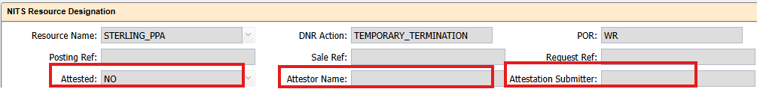

# Data Entry Errors (Red error message where TSR did not submit)

## Service:

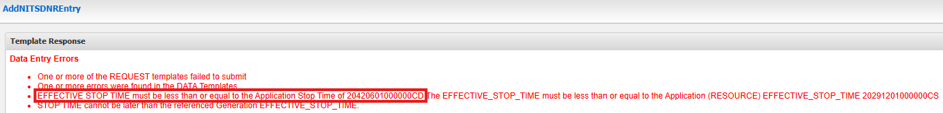

**Typical reason for the error message:**

* The Stop time of the DNR you are trying to submit is past the Stop Time of the current Network Service Stop time, either the current NewNITSApplication or ModifyService TSR.

**Resolution**:

* If the Stop time of your DNR is correct, submit a ModifyNITSService and extend the Network service to at least the Stop time of the DNR you are trying to submit.

## NITSResource:

**Typical reason for the error message:**

* The Stop time of the DNR you are trying to submit is past the Stop Time of the current AddNITSResource Stop time

**Resolution**:

* If the Stop time of your DNR is correct, you will need to submit a ModifyNITSResource and extend the Resource to at least the Stop time of the DNR you are trying to submit.

## AddNITSGeneration:

**Typical reason for the error message:**

* The Stop time of the DNR you are trying to submit is past the Stop Time of the current AddNITSGeneration Stop time

**Resolution**:

* If the Stop time of your DNR is correct, you will need to submit a ModifyNITSGeneration and extend the Resource to at least the Stop time of the DNR you are trying to submit.

# Terminatenitsdnr :

**Typical reason for the error message:**

* The MW amount for a TERMINATENITSDNR must be a negative amount, signifying the amount of MW you choose to terminate (may be partial or all).

**Resolution**:

* Change the MW amount to a Negative value or MW choosing to terminate.

# Add/modify nitsgen

* NITS Generation Designated

**Reason for the error message:**

* The MW amounts in this TSR are less than the current MW amount of the DNR associated with this Resource.

**Resolution**:

* Check the current DNR amount to make sure that MW amount matches the MW amount in your ModifyNITSGeneration request

**Typical Start/stop time issues (these scenarios will not make the TSR deficient but SPP cannot accept)**

**Start Day:** First day of the month, not in the middle for a long-term request.

**Stop Day:** Stop day should be at the end of the month, not in the middle for a long-term request

**Current Start/Stop time of TSR:**

*Times are entered in Central Standard time zone (CS) or Central Daylight time zone (CD). The way OASIS is configured through your settings on your PC will depend on the default display time zone.*

Due to daylight savings time, and the users configuration of OASIS (default to either CS or CD) There may be difference in start and end date and time depending on the month in which the TSR is to either begin or end.

Start and stop times should be configured in the following manner based on OASIS configuration to maintain the proper start/stop time.

**During Daylight Savings time:**

In the U.S., daylight saving time:

**Starts** on the **second Sunday in March**

E**nds** on the **first Sunday in November**.

|  |  |  |
| --- | --- | --- |
| **OASIS Configuration** | **Start Date/Time** | **Stop Date/Time** |
| **CS** | 05/31/2026 23:00:00 | 06/31/2036 23:00:00 |
| **CD** | 08/01/2026 00:00:00 | 10/01/2036 00:00:00 |

**During Standard time:**

|  |  |  |
| --- | --- | --- |
| **OASIS Configuration** | **Start Date/Time** | **Stop Date/Time** |
| **CS** | 12/01/2026 00:00:00 | 01/01/2036 00:00:00 |
| **CD** | 02/01/2026 01:00:00 | 02/01/2036 01:00:00 |